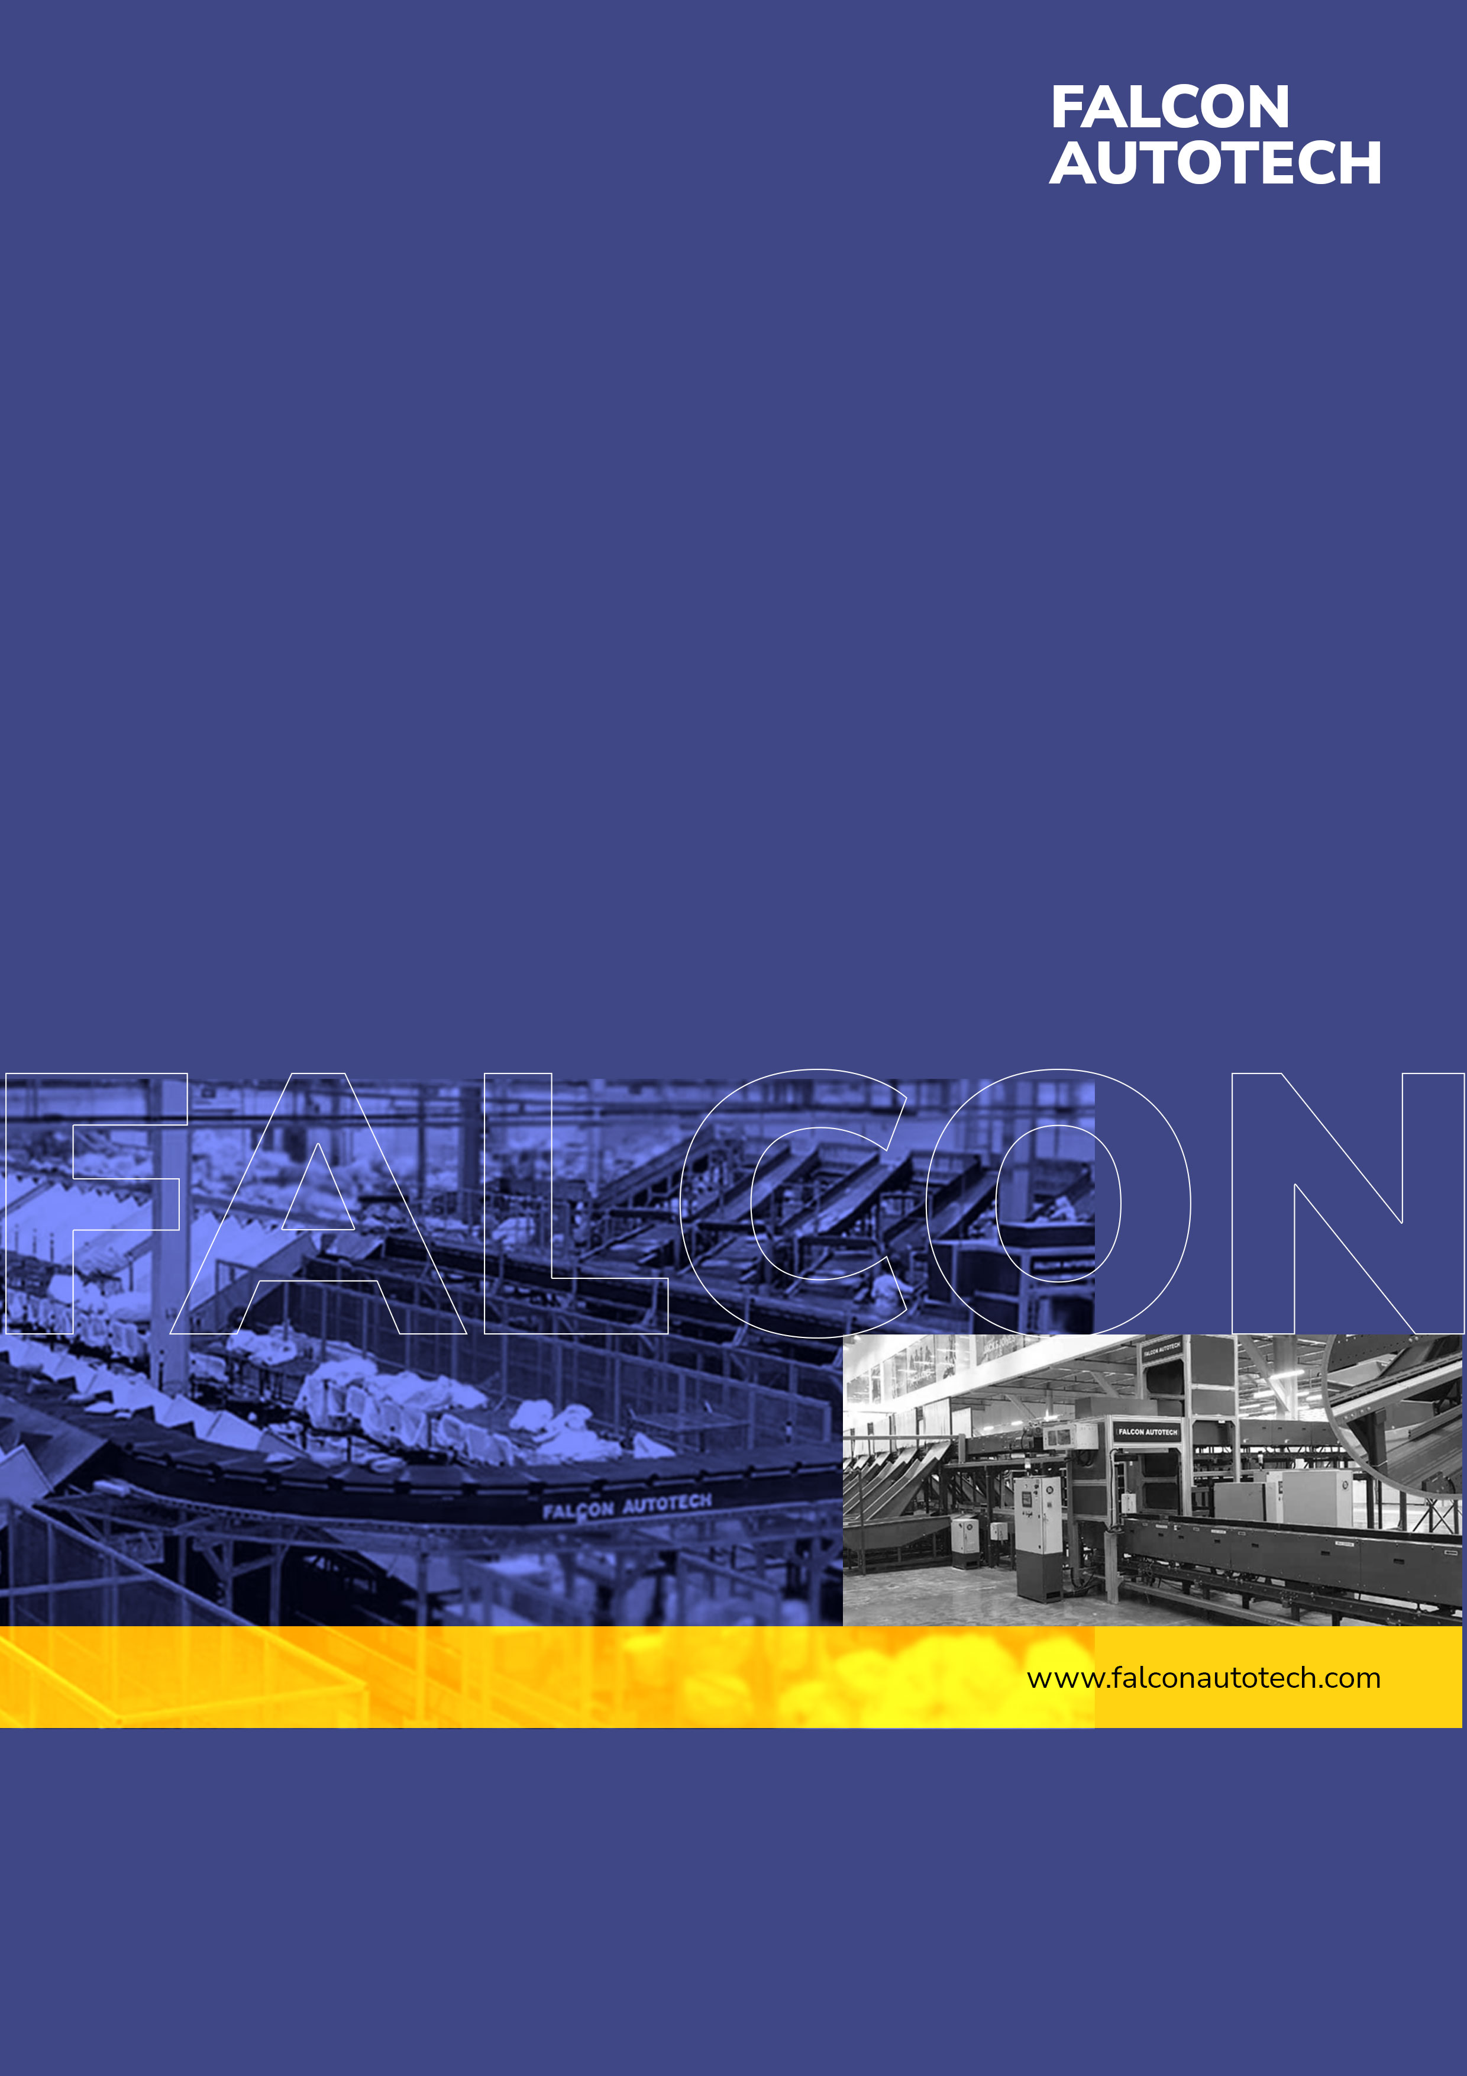
Kind Attention –
FALCON’s Response to RFQ
DHL for Supply of Conveyor Automation System
November 5, 2025

Mr. Nishant Kumar

M/s DHL

Offer Ref: F23_00167; Date 14.02.2023
Subject – Techno-Commercial Offer for Conveyor Automation

Dear Team,

We are pleased to submit our Techno-Commercial Offer in response to your RFQ
As you will note, we have studied your requirements in great depth and, along with the information collected during the workshops and calls with you, we have put together a detailed technical proposal laid out in various sections and sequenced to enable you to understand our proposed solution and to re-enforce our commitment to be your partner in this strategic initiative.
In subsequent sections, we have highlighted the capabilities and experiences of Falcon Autotech with sections on our Automation Technologies and references.
To conclude, I would like to add my personal commitment, on behalf of Falcon Autotech. As we move through the RFP process, please do not hesitate to contact me and my team. We will be pleased to assist you for any further information or clarifications that you might have.
tails
Contact Person : Sanyog Pratap Singh
Title : Asst. Manager
Mobile : +91- 8750052591
Email : Sanyog.singh@falconautoonline.com
Company Details
Company Name : Falcon Autotech Pvt. Ltd.
Regd. Office : 57, Nimri Colony, Double Storey Flats, Delhi – 110052
Website : www.falconautotech.com
LinkedIn ID : https://www.linkedin.com/company/falconautotech/mycompany/
Copyright © 2022 Falcon Autotech Pvt. Ltd. All rights reserved. Falcon Autotech Pvt. Ltd. and its affiliated and group entities consists of various companies in India and abroad (collectively “Falcon”). All intellectual properties in this document are owned by Falcon in India and abroad. Any use, copying, modification, publication, distribution of contents contained in this document is expressly prohibited.
Table of Contents
1. About Falcon 4
2. Handled Parcel Spectrumions Minimum Maximum 11
2.1 Product size Conveyable on the entire system. 11
2.2 Parcels to be loaded on Conveyor/Sorter shall have the following characteristics: 11
2.3 Parcel not loadable on the system 11
3. Proposed System Description 12
3.1 Objective 12
3.2 Summary of the System 12
3.3 Main benefits of the proposed solution 12
4. Layout View 13
4.1 13
5. Proposed System Capacity 13
5.1 System Capacity 13
6. System Components 14
6.1 PVC Belt Conveyor 14
1. Proposed System Technical Details/BOM 16
2. Key Component Makes 16
3. Safety 17
3.1 Emergency Pull cord 17
3.2 E-Stops 17
4. Commercial Terms 18
4.1 Price Sheet 18
4.2 Payment Terms 19
5. Warranty Period 19
6. Exclusions 20

About Falcon
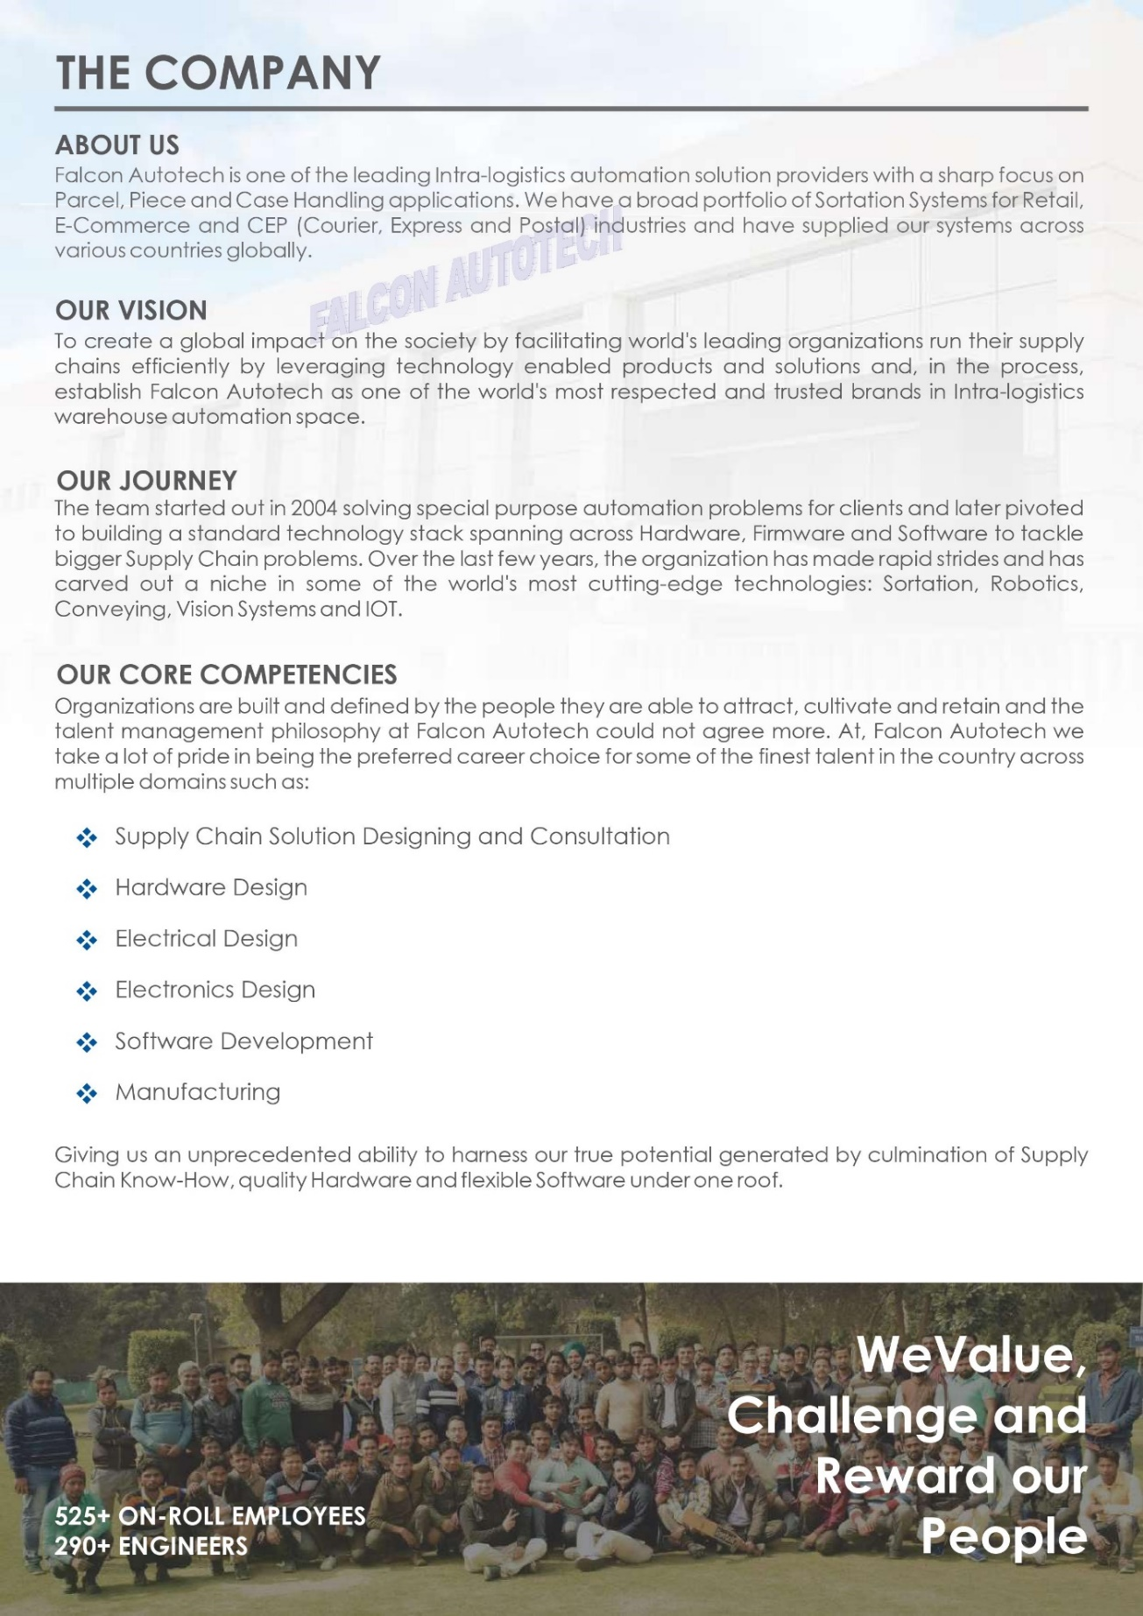
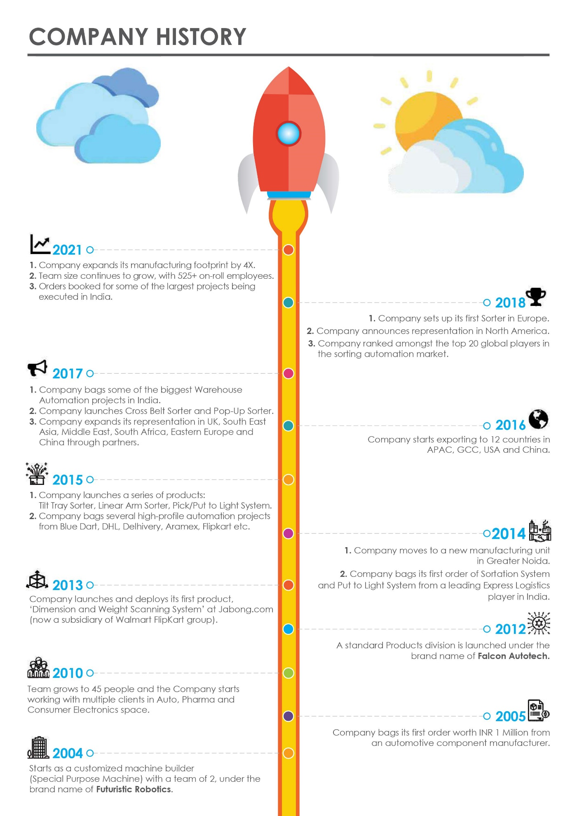
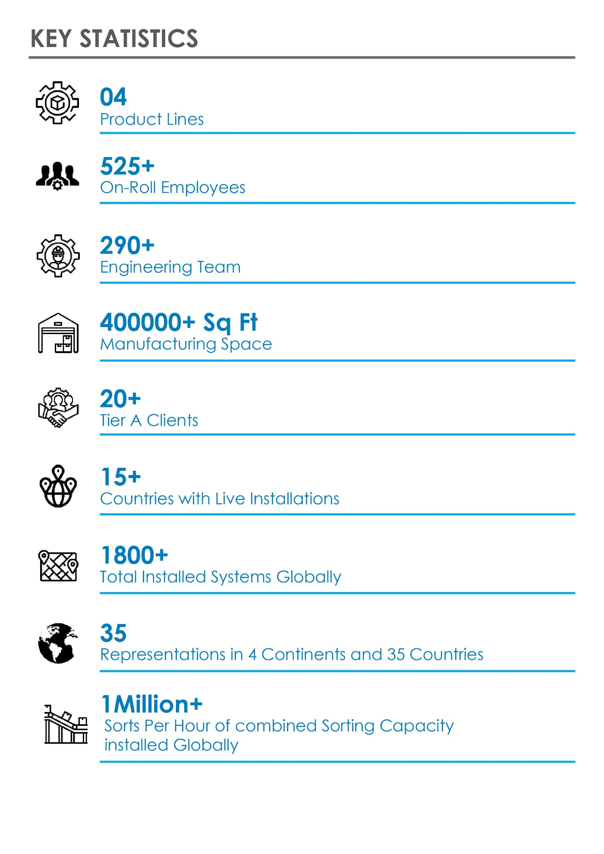
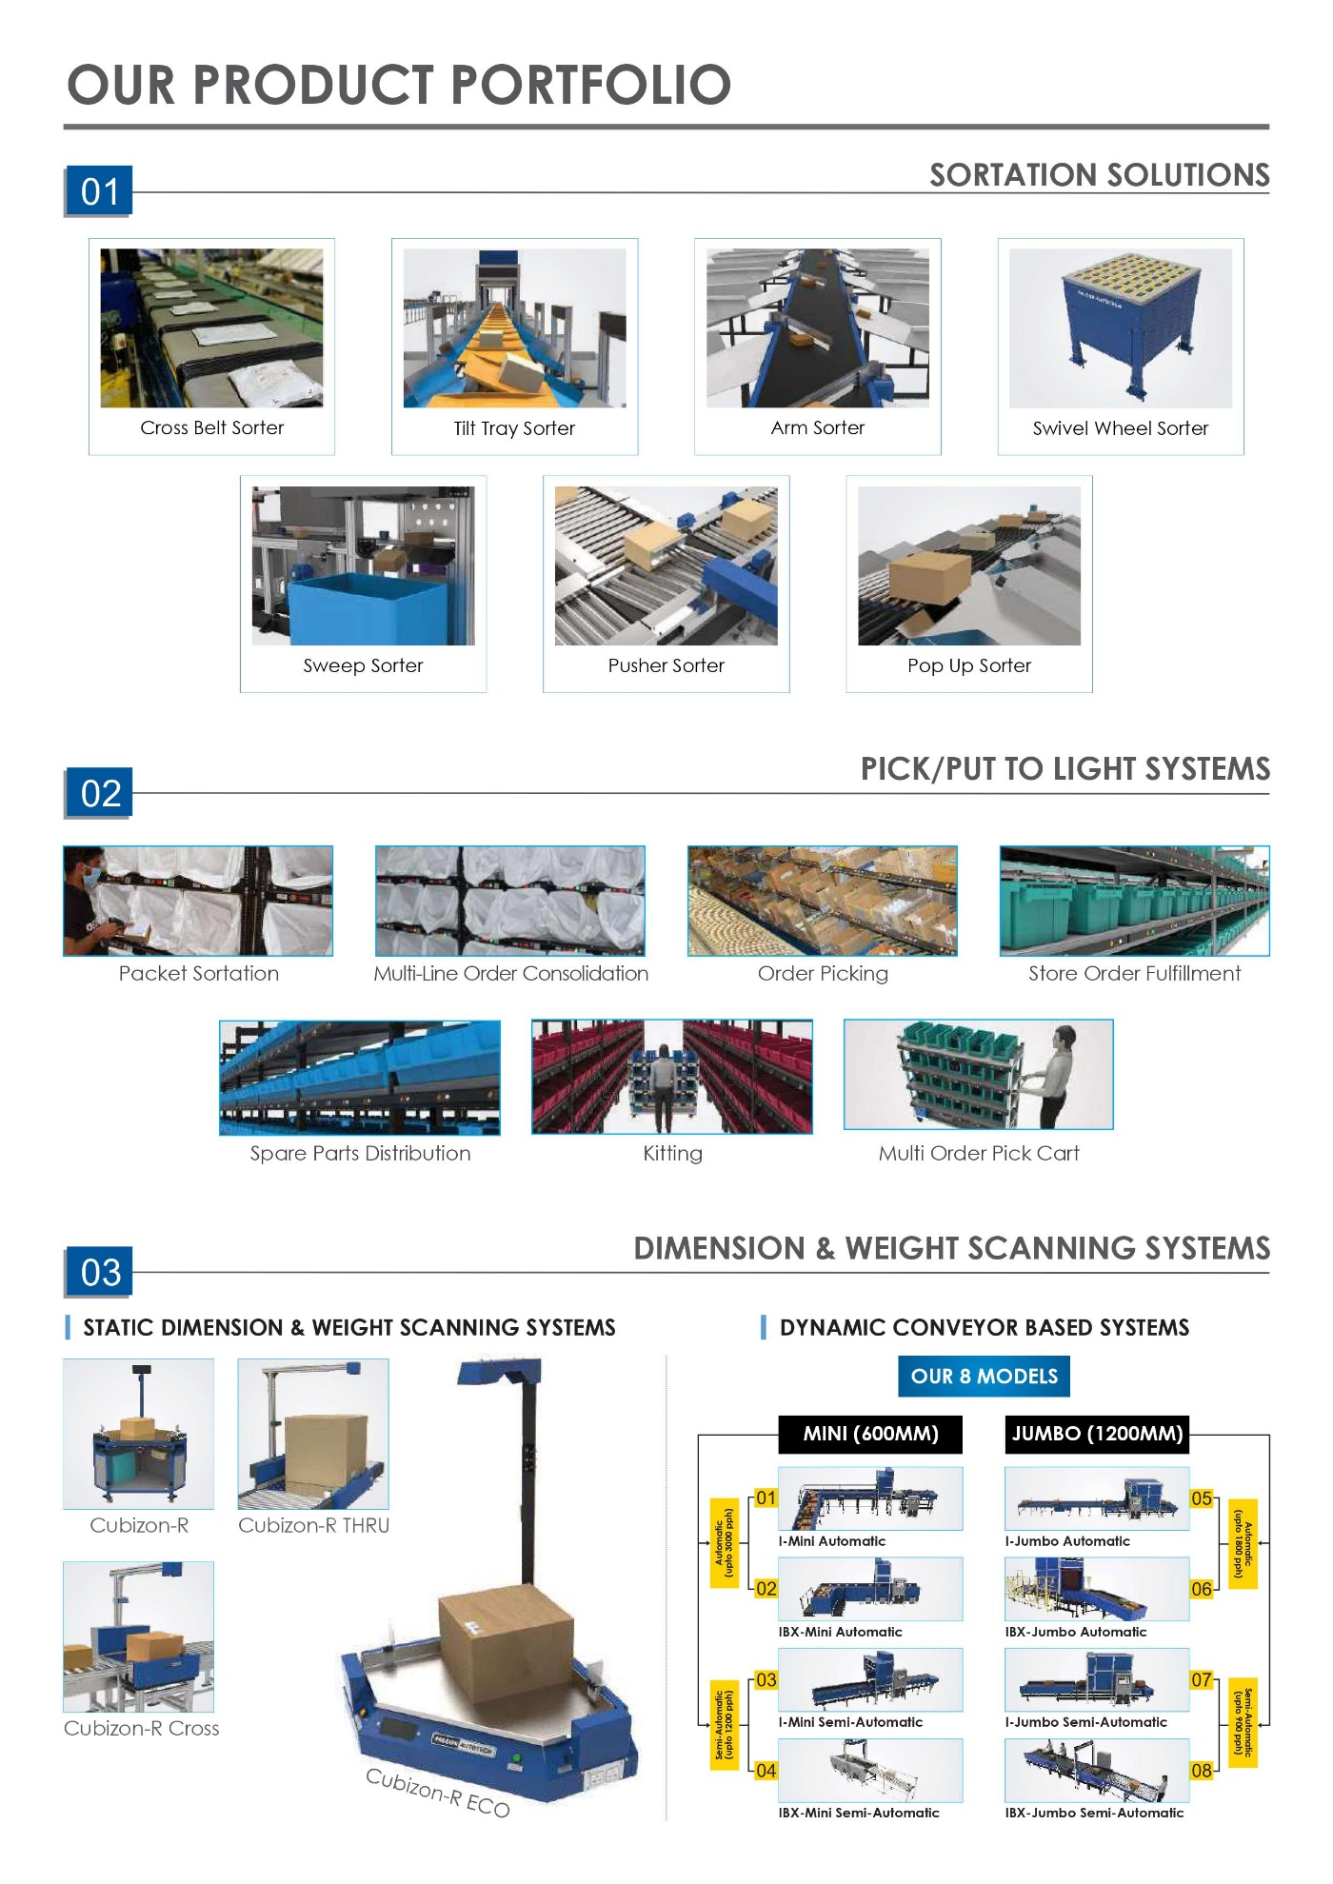
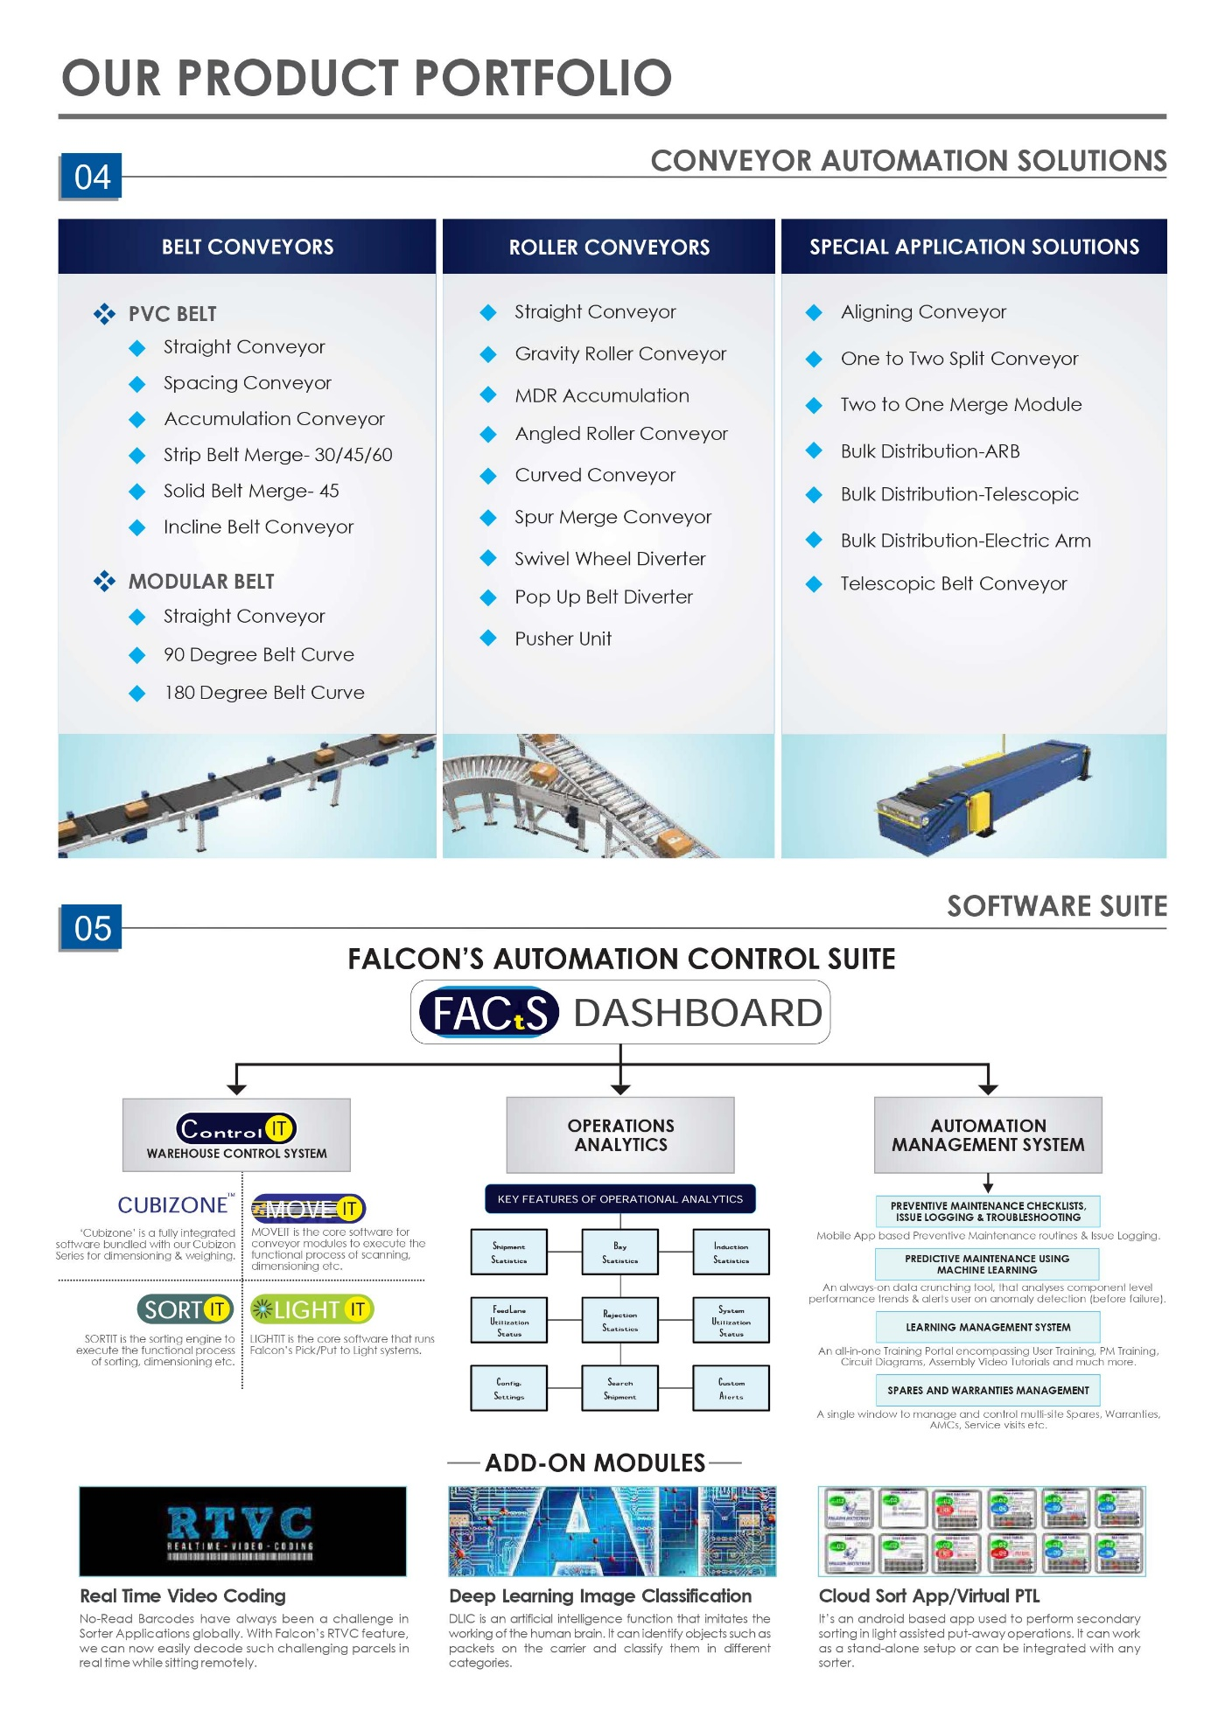
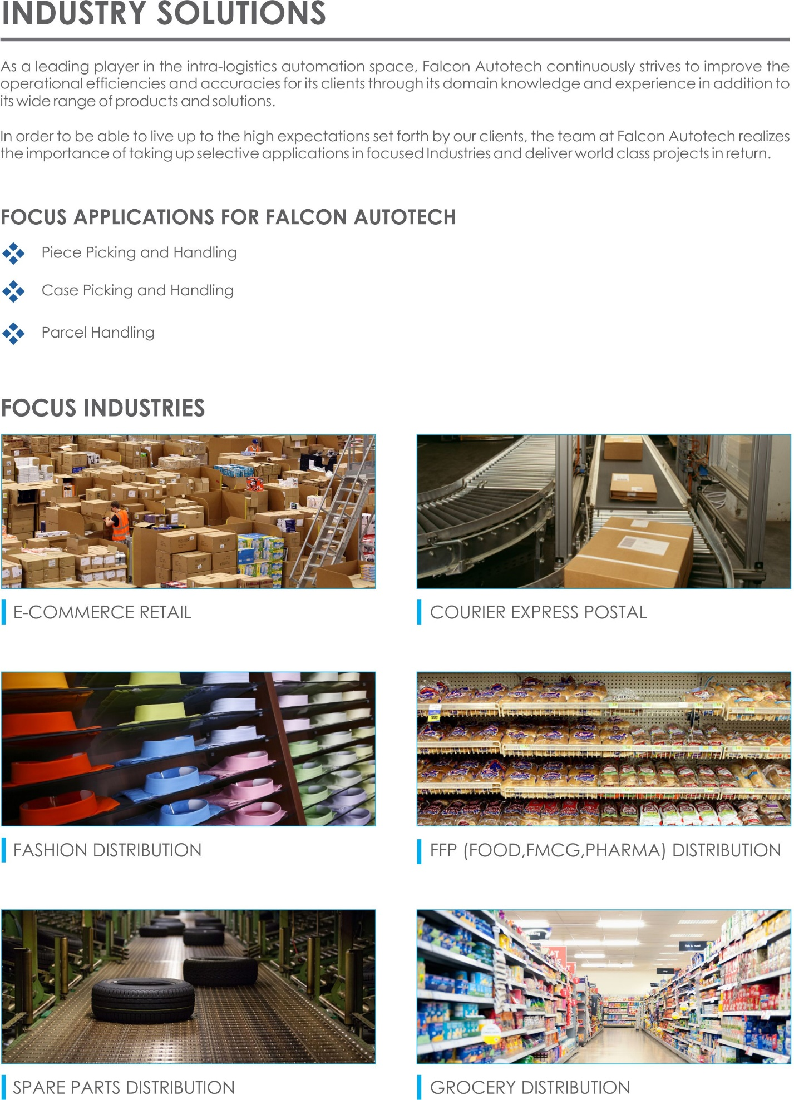
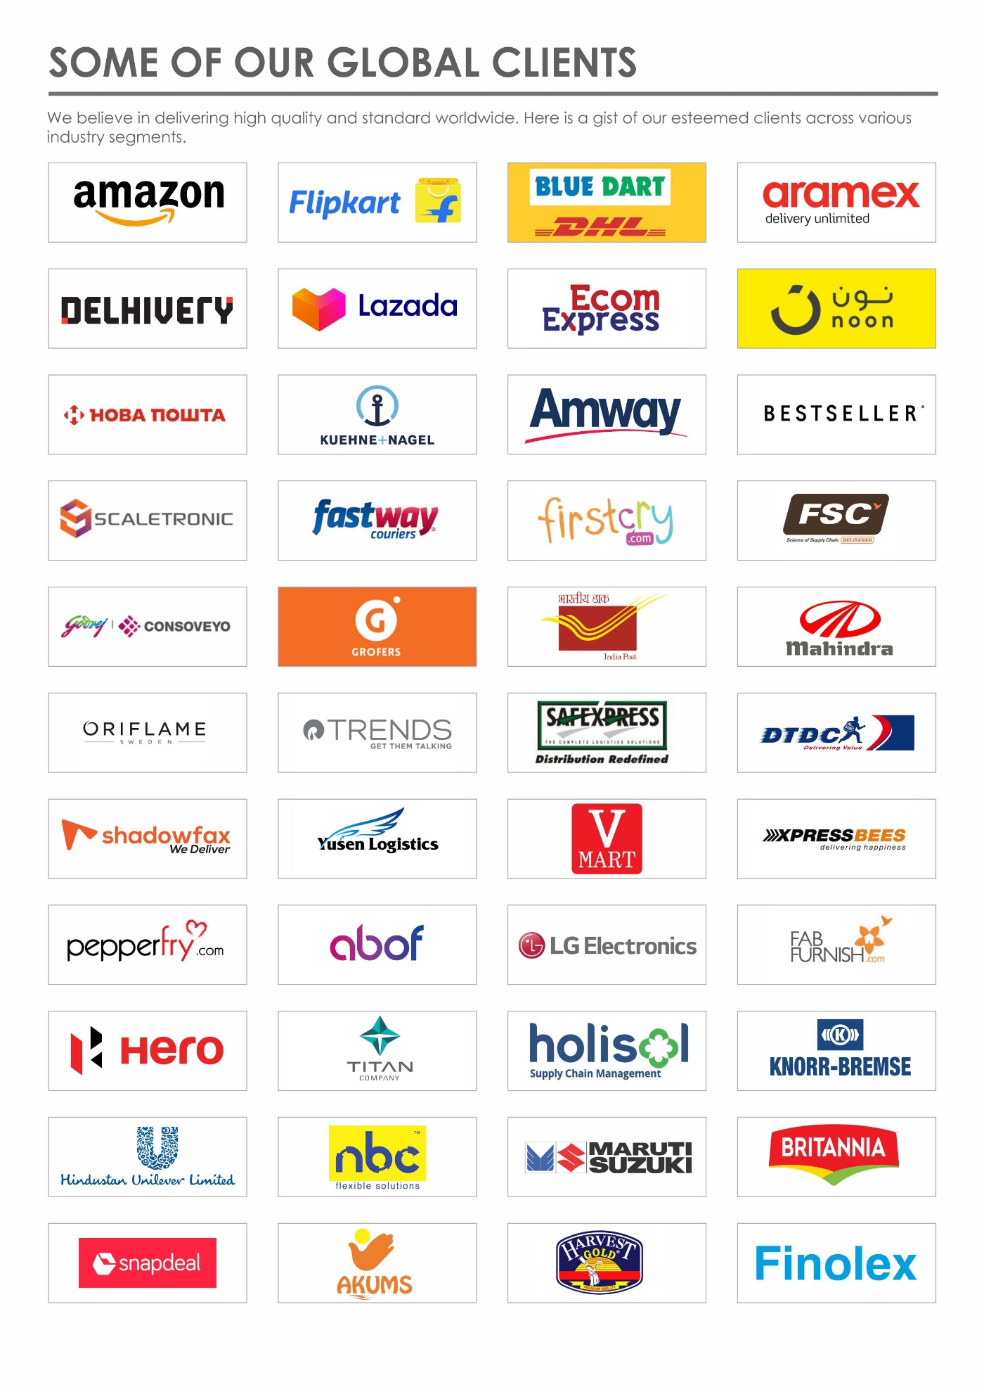

Handled Parcel Spectrumions Minimum Maximum

Product size Conveyable on the entire system.

Max Length | mm | NA
Max Width | mm | 600
Max Height | mm | NA
Max Weight | Kg | 08
Min length | mm | NA
Min Width | mm | NA
Min Height | mm | NA
Min Weight | Kg | 02

Parcels to be loaded on Conveyor/Sorter shall have the following characteristics:

- Centre of Gravity of items must not move during conveyance or sorting.
- Item must not have magnetic content; otherwise behaviour of parcel cannot be guaranteed.
- Liquid or fragile material, to avoid breaking, spillage or leakage, such as wine bottles, metal cans of paint are designated as non- conveyable items.
- Parcels shall be perfectly and safely packaged: protrusion or open surfaces are not allowed.
- Plastic ropes shall be perfectly adherent to the surface of the package.
- All items with the risk of being damaged during the transport on an automatic conveying/sorting system or damaging the system. They must be robust enough to avoid disintegration of container material and loose of contents in the conveying/sorting process.
- Item packaging shall have enough grip to be handled on the belts during the acceleration and
referencing phases.
- Items shall not have slippery surfaces and must be able to withstand acceleration of the items on the belt during the start-stop phases (accelerations up to 0.5 g shall be assured without any sliding or tumbling of the items on the belt conveyor).
- The parcels must have at least one flat and regular surface providing enough stability during conveyance.
- All shapes are permitted except spherical, cylindrical, or alike unstable items & shapes.
- All usual packaging materials are permitted (including paper, carton, plastics, plastic foil, rope, tape, textile, and wood)

Parcel not loadable on the system
All products that are not within the range as described here, are considered non- conveyable products, and must be taken out of the main sorter flow by the operators.
- Unstable items with a risk to roll or tumble on the sorting system, such as spherical or cylindrical items
- Items that have a spherical or cylindrical shape.
- Items that are packed in material that can damage the conveyors or the sorter.
- Items that have sharp points (e.g. Nails) or sharp edges, that can damage the conveyors or the sorter.
- Fragile parcels with contents not sufficiently secured
- Items that have been classified as dangerous are designated.
- Wet items are designated.
- Items with anti-slip treatment.
- Items with protruding parts.
- Items with sharp edges.
- Inadequately packed items that could be damaged during automatic transportation.
- Electrostatically loaded items.
- Loose parts on loads and load carriers, such as adhesive tape, stickers, slips of paper, straps, wrap foil etc. are designated as non- conveyable items.

Proposed System Description

Objective
The purpose of this proposal is to present the design, manufacturing, installation, commissioning, testing and acceptance testing of the Conveyor automation system to handle Corrugated boxes as per specifications shared by DHL.
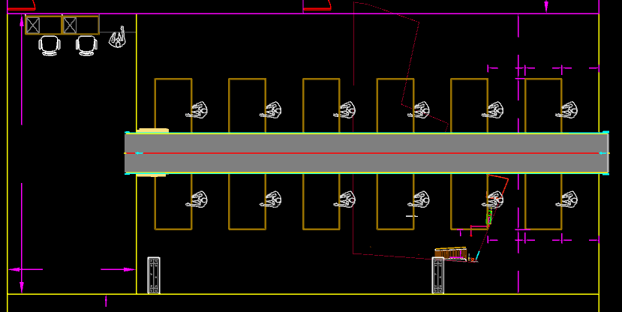

Summary of the System

Solution is designed to transport the corrugated box containing Electronic devices along its length in specified direction.

Main benefits of the proposed solution
The proposed solution has the following advantages:
- Low occupancy of floor space in the building
- FALCON’s system can adapt with changing business requirements by adjusting its speed to match the operational throughput requirement, thereby leading to Power Savings and reduced system Wear & Tear

Layout View
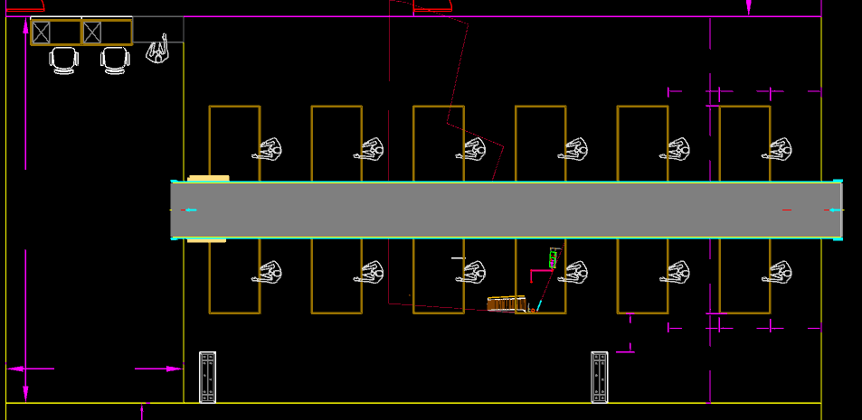
1
Legend
1 – Belt Conveyor

Proposed System Capacity

System Capacity
Activity | Max Speed
Belt Conveyor | 2m/s

System Components

PVC Belt Conveyor
Falcon’s Belt Conveyors are modular & robust in design. MS profile is used to build conveyor frame.
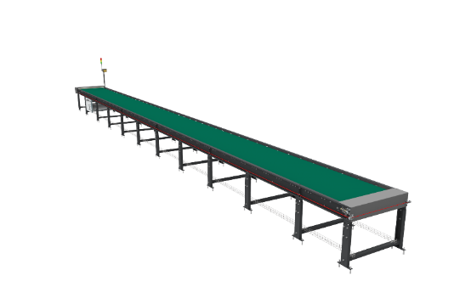
Some Salient Features of Falcon’s Belt conveyor:
- Low Noise
- Maximum uptime.
- Minimal maintenance
- High safety standards.
- Fastest ROI.

Specification | UOM | Remark
Manufacturer Name | Name | Falcon Autotech
Material of Roller | Type | MS Rollers with Zinc Plating
MOC of Belt | Type | PVC
Belt Thickness | mm | 3
Belt Finish | Type | Matt Finish
Belt Joint Type | Type | Vulcanized, Endless Belts
Belt Make/Model No. | Make | FORBO/DERCO
Chassis | mm | MS, 3mm Thick, Powder Coated-75 Microns
Idler Roller Pitch on running side (Top) | mm | 480
Idler Roller Pitch on return side (Bottom) | mm | 1200
Idler Roller Specs | Spec | Dia.50.8, shaft-12 mm, bearing-6301
End Rollers | Spec | Dia 81.2 x 2.85 Thick, 30mm Shaft Dia, & Bearing Size-UCFH206D1, MOC-EN9, Zinc Plated -25 microns
Drive Rollers | Spec | OUTER Dia 178 PIPE Dia 168x5 Thick, 40mm Shaft Dia, & Bearing Size-UCF208D1, MOC(SHAFT)-EN9, NEOPRENE RUBBER COATING
Tensioning Rollers | Spec | Dia 81.2 x 2.85 Thick, 25mm Shaft Dia, & Bearing Size-UCT205D1, MOC-MS, Zinc Plated -25 microns
Take Up Rollers | Spec | Dia 81.2 x 2.85 Thick, 25mm Shaft Dia, & Bearing Size-6305-LLU, MOC-MS, Zinc Plated -25 microns
Type of Drive | Type | Rubberized
Angle of wrap/Contact - Belt with Drive pulley | Deg | >180 deg
Motor Shaft | MOC | EN9 Shaft material,
Conveyor Under guarding | Spec | MOC-MS, 0.8 to 1mm thickness, Steel Stiffeners at every 600mm to avoid the sagging due to self-weight
Load capacity per unit length of Conveyor | kg/m | 50
Type of Guides | Type | Steel guides at 50mm/400mm height basis the position of conveyor on both sides from Conveyor Belt Surface.
Drive Power Rating | kW | Motor Rating depends on Length of the Conveyor
Type of Motor | Type | AC Geared Motor
Type of Drive System | Type | Direct Shaft Mounted Motor
Type of Drive | Type | Torque Arm type
Gear Motor | make | Sew
Drive | make | Lenze/Siemens/Omron/Allen Bradly
Insulation Class | Type | Yes
Conveyor Speed | m/s | Variable speed to meet TPH requirements
Type of Mounts | Type | Fixed Heights Legs with Grouting Provisions

Proposed System Technical Details/BOM

Mechanics
Qty. | Description | Value
1 | Conveyor Automation  01 x Powered Belt conveyor: L-14.9m | Width- 1200 mm  Ht.800 mm
Controls
1 | Controls and Wiring  Switches  Drive panels  Internal & Field Wiring | Included

Key Component Makes
Component | Make
VFD | Siemens/Omron/Lenze/AB
Switchgear | Schneider
Geared Motors | SEW
Belt Make | Movex/forbo
Bearings | NTN/SKF

Commercial Terms

Price Sheet

Sr. No | Component | Total (INR)
1 | Conveyors | ₹ 8,49,321
2 | Toolkit | ₹ 39,600
3 | Installation & Commissioning | ₹ 1,04,004
4 | Packaging & Forwarding | ₹ 1,17,778
5 | Project Management and Engineering Charges | ₹ 10,107
Total |  | ₹ 10,20,810

The Total Price is to be understood.
- Freight charges: Included
- GST will be charged extra @ 18%
- Packing and Forwarding: Included
- Installation and Commissioning: Included.
- Price is valid for 60 days from the date of proposal
Our Price does not include taxes, and duties, import duties, charges, fees, taxes etc. charged by authorities outside India for deliveries and services. Same shall be borne & paid by client itself.
*Material Unloading & Laydown area is in customer scope

Payment Terms
The Supplier Quotation is based on the following payment schedule:
Stage 1: 50% Advance along with PO.
Stage 2: 50% along with 100% Taxes prior to dispatch..

Warranty Period
Falcons offered System comes with a standard warranty of 1 year (Starts from the date of beneficiary use) and post completion of warranty, customer can opt for Extended warranty. Warranty covers the following support:
- 24 X 7 Telephonic, Email and Remote Service Support when required
- Regular Software updates and Bug Fixes.
- Supply of Mechanical and Electrical components in case of failure (excluding damages as mentioned in Exclusion Clause)
The warranty does not apply to replacement or repair of:
- Normal wear and tear.
- Consumables.
- Faulty articles continued:
  - Failure to comply with the manufacturer's recommendations (logistics documentation, Technical Information Note, retrofit document) and the rules of the trade.
  - Negligence or abnormal use of equipment.
  - Anomalies produced by an environment of use, storage or transport that does not comply with the specifications or recommendations of Falcon: packaging, temperature, hygrometry, sector, insulation, etc.
  - A defect due to a cause external to the supplies and services of Falcon.
- Equipment other than that supplied by Falcon.
- Items that can be repaired exclusively by Falcon that have been repaired or attempted repairs other than those carried out by Falcon.
- Items that fail due to normal wear and tear of one or more of its components or whose tamper-evident seals (varnish, strip, etc.) have been broken or whose serial numbers have been removed or modified.
- Items damaged during transport to Falcon due to the use of unsuitable packaging.

Exclusions
The scope of supply includes all parts which are defined in the Supplier’s quotation.

All other parts which are not defined in the Supplier’s quotation do not belong to the Supplier’s scope of supply and are excluded. The following parts are also excluded:

- Servers
- Building infrastructure; building structure, doors, fire exits, levelling devices, building extinguisher and fire alarm system, building heating and lighting system.
- Electrical power supply and wiring to the main control cabinets
- UPS for Controls and Drives
- Electrical Power for Installation
- Network Cabling up to the Main Server Rack
- Intermediate wiring to parts which are to be supplied by the Purchaser/others
- Emergency/Uninterruptable power supply
- Fire-alarm and fire protection devices
- Traffic and route markings
- Laydown Area
- Ram protection devices
- Cat walks, bridges, maintenance aisles and platforms- If not specified
- Assembly tools like forklifts and hoisting machines
- All kind of network incl. Local Area Network (LAN/WLAN), exceeding the scope described in Scope of Supply
- Any Kind of Civil work
- Any adjustment of the Supplier’s scope of supply to local rules and regulations
- X-Ray machines
- Roller cages/ Pallets
- Simulation and 3D animation of the sorter system
- Interface with other equipment not specified in this offer.
- Provision of facilities for the control room (furniture, air conditioning, heating, etc.).
- The supply and installation of fencing around the different corridors.
- Any item specifically indicated as not forming part of the subject matter of the Seller's supply in the offer documentation.

